STANDARD: Potentially Unsafe Code - Integer Operation Without Overflow Check
Line: 653 - C:\_data\Intranet_swz-appbuilder-clover.08042019\swz-appbuilder-clover\swz.Clover.StarterApplication\Controllers\DeploymentController.cs
The code carries out integer operations without enabling overflow defences. Manually review the code to ensure that it is safe
for (int i = 0; i < colCount; i = i + 200)

STANDARD: Potentially Unsafe Code - Integer Operation Without Overflow Check
Line: 672 - C:\_data\Intranet_swz-appbuilder-clover.08042019\swz-appbuilder-clover\swz.Clover.StarterApplication\Controllers\DeploymentController.cs
The code carries out integer operations without enabling overflow defences. Manually review the code to ensure that it is safe
for (int j = 0; j < items.Count; j++)

STANDARD: Potentially Unsafe Code - Integer Operation Without Overflow Check
Line: 995 - C:\_data\Intranet_swz-appbuilder-clover.08042019\swz-appbuilder-clover\swz.Clover.StarterApplication\Controllers\DeploymentController.cs
The code carries out integer operations without enabling overflow defences. Manually review the code to ensure that it is safe
for (int i = 0; i < recordsUIDs.Count; i = i + 500)

STANDARD: Potentially Unsafe Code - Integer Operation Without Overflow Check
Line: 1375 - C:\_data\Intranet_swz-appbuilder-clover.08042019\swz-appbuilder-clover\swz.Clover.StarterApplication\Controllers\DeploymentController.cs
The code carries out integer operations without enabling overflow defences. Manually review the code to ensure that it is safe
for (int i = 0; i < dplySampleIds.Count; i = i + 500)

STANDARD: Potentially Unsafe Code - Integer Operation Without Overflow Check
Line: 1017 - C:\_data\Intranet_swz-appbuilder-clover.08042019\swz-appbuilder-clover\swz.Clover.StarterApplication\Controllers\ListController.cs
The code carries out integer operations without enabling overflow defences. Manually review the code to ensure that it is safe
for (int i = 0; i < dyUpdateObjectsList.Count; i = i + 500)

STANDARD: Potentially Unsafe Code - Integer Operation Without Overflow Check
Line: 1180 - C:\_data\Intranet_swz-appbuilder-clover.08042019\swz-appbuilder-clover\swz.Clover.StarterApplication\Controllers\ListController.cs
The code carries out integer operations without enabling overflow defences. Manually review the code to ensure that it is safe
for (int i = 0; i < dyUpdateObjectsList.Count; i = i + 500)

STANDARD: Potentially Unsafe Code - Integer Operation Without Overflow Check
Line: 1820 - C:\_data\Intranet_swz-appbuilder-clover.08042019\swz-appbuilder-clover\swz.Clover.StarterApplication\Controllers\ListController.cs
The code carries out integer operations without enabling overflow defences. Manually review the code to ensure that it is safe
for (int i = 0; i < dyUpdateObjectsList.Count; i = i + 500)

STANDARD: Potentially Unsafe Code - Integer Operation Without Overflow Check
Line: 1425 - C:\_data\Intranet_swz-appbuilder-clover.08042019\swz-appbuilder-clover\swz.Clover.StarterApplication\Controllers\ReportController.cs
The code carries out integer operations without enabling overflow defences. Manually review the code to ensure that it is safe
for (int j = 0; j < elements.Count; j++)

STANDARD: Potentially Unsafe Code - Integer Operation Without Overflow Check
Line: 1547 - C:\_data\Intranet_swz-appbuilder-clover.08042019\swz-appbuilder-clover\swz.Clover.StarterApplication\Controllers\ReportController.cs
The code carries out integer operations without enabling overflow defences. Manually review the code to ensure that it is safe
for (int a = 0; a < LastDateofWeek.Count; a++)

STANDARD: Potentially Unsafe Code - Integer Operation Without Overflow Check
Line: 2186 - C:\_data\Intranet_swz-appbuilder-clover.08042019\swz-appbuilder-clover\swz.Clover.StarterApplication\Controllers\ReportController.cs
The code carries out integer operations without enabling overflow defences. Manually review the code to ensure that it is safe
for (int a = 0; a < LastDateofWeek.Count; a++)

STANDARD: Potentially Unsafe Code - Integer Operation Without Overflow Check
Line: 3719 - C:\_data\Intranet_swz-appbuilder-clover.08042019\swz-appbuilder-clover\swz.Clover.StarterApplication\Controllers\ReportController.cs
The code carries out integer operations without enabling overflow defences. Manually review the code to ensure that it is safe
for (int i = 0; i < dataElements.Count; i++)

FIX: Add integer overflow check in the project level:

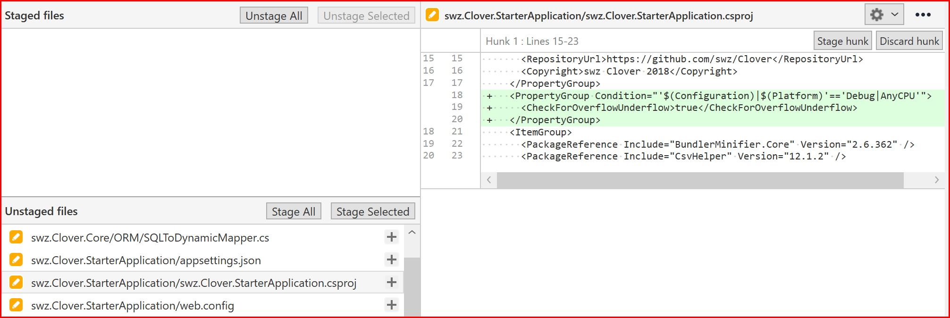

This will do the overflow check for all above loops. Please refer to: https://docs.microsoft.com/en-us/visualstudio/code-quality/ca2233?view=vs-2019, where it is mentioned:

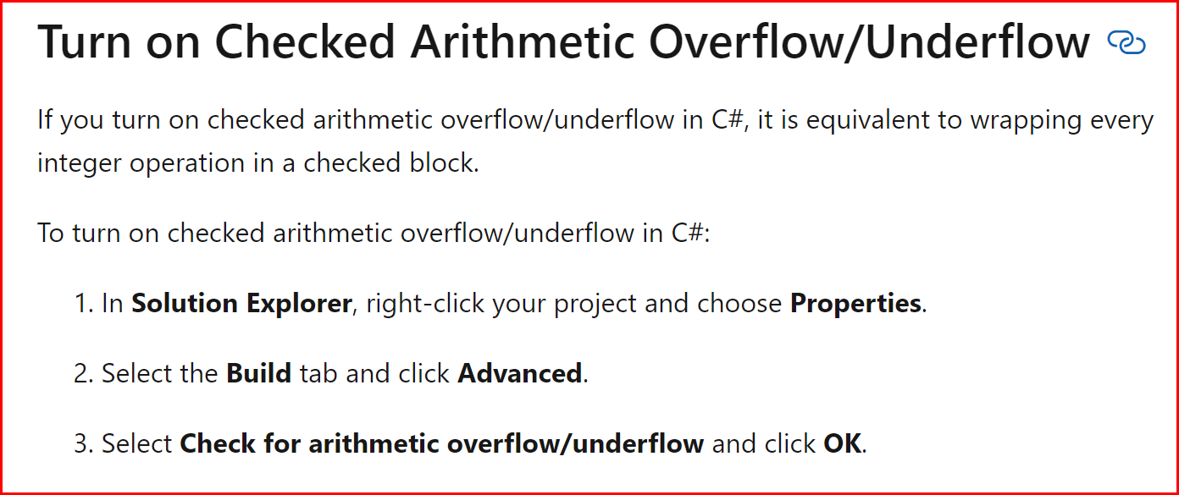

Please know that code scan will still flag the above items due to its limitation.

MEDIUM: Potentially Unsafe Code - Thread Locks - Possible Performance Impact
Line: 717 - C:\_data\Intranet_swz-appbuilder-clover.08042019\swz-appbuilder-clover\swz.Clover.StarterApplication\Controllers\DeploymentController.cs
There are 38 lines of code in the locked code block. Manually check the code to ensure any shared resources are not being locked unnecessarily.

Note: The lock is deliberately introduced to allow only one thread to perform expensive operations

HIGH: Potentially Unsafe Code - Application Appears to Log User Passwords
Line: 20 - C:\_data\Intranet_swz-appbuilder-clover.08042019\swz-appbuilder-clover\swz.Clover.StarterApplication\Controllers\RespChangePassword.cs
The application appears to write user passwords to logfiles creating a risk of credential theft.
private readonly ILogger _logger = ApplicationLogging.CreateLogger("RespChangePasswordController");

Note: This line is to create a logger object for RespChangePasswordController class to log exceptions, not passwords

